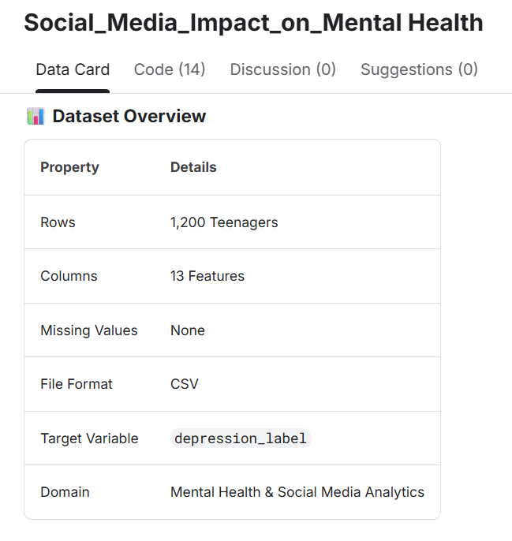
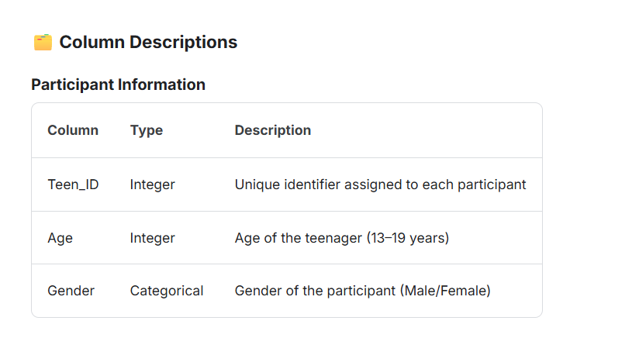
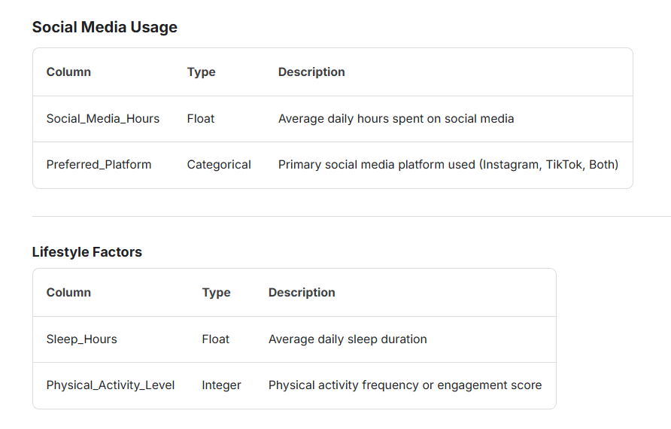
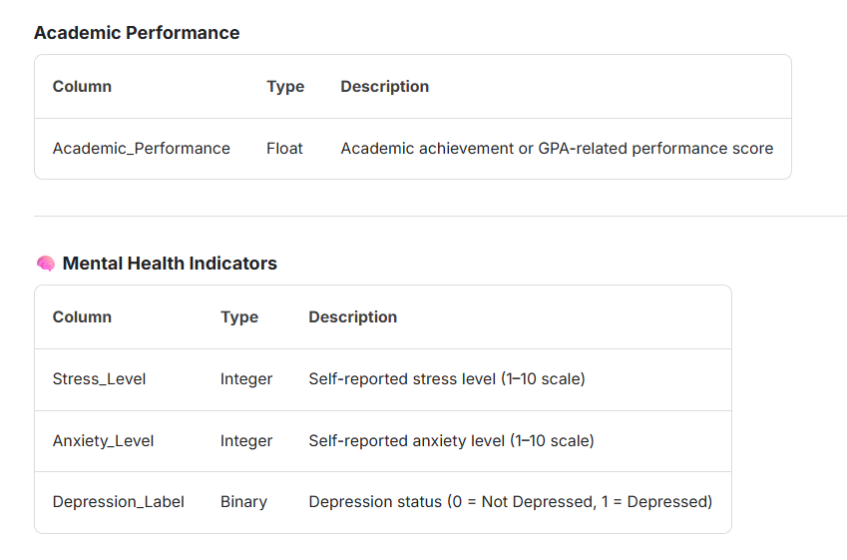
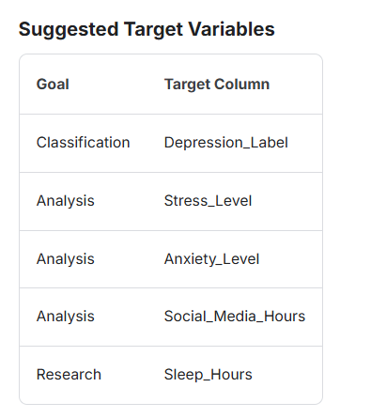

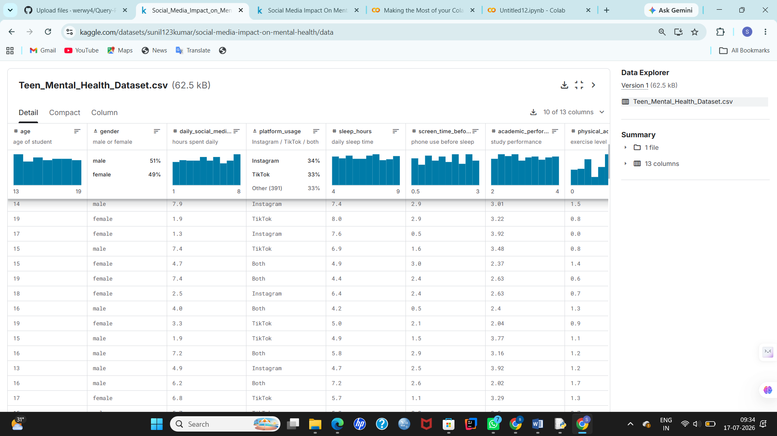

Code:

1.Handling Missing Values:
import numpy as np
import pandas as pd
import matplotlib.pyplot as plt
import seaborn as sns
df = pd.read_csv("Teen_Mental_Health_Dataset.csv")
df.head()
df.tail(5)
df.sample(5)
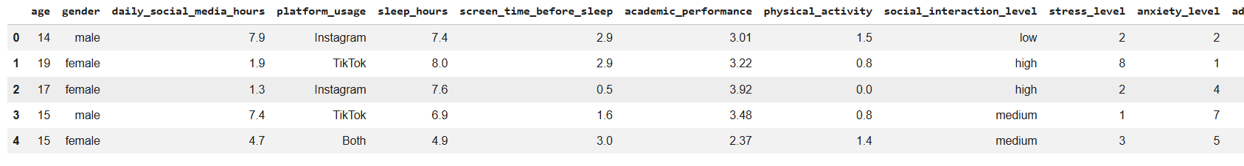
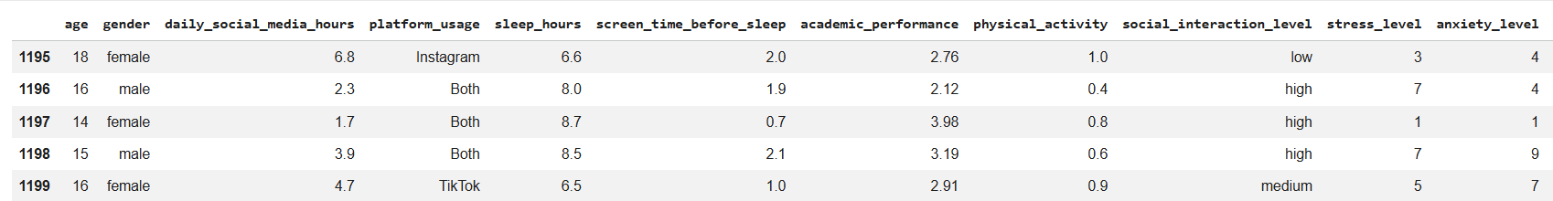

df.info()
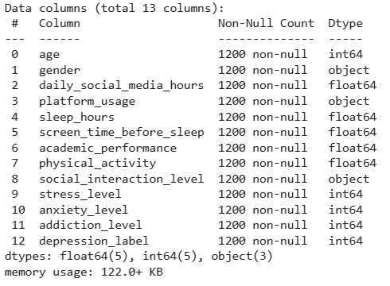
df.duplicated().sum()
df.describe()
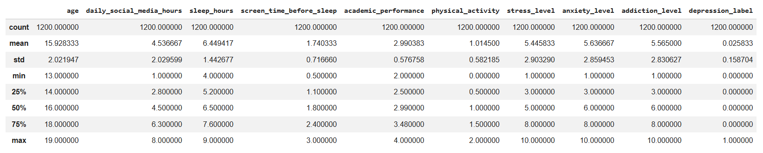
df.corr(numeric_only = True)
missing_values_count = df.isnull().sum()
missing_values_count[0:10]
total_cells = np.prod(df.shape)
total_missing = missing_values_count.sum()

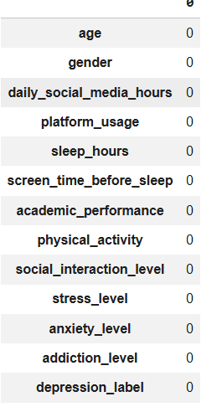
# percent of data that is missing
percent_missing = (total_missing/total_cells) * 100
print(percent_missing)

2.Scaling and Normalisation
import pandas as pd
import numpy as np
from scipy import stats
from mlxtend.preprocessing import minmax_scaling
import seaborn as sns
import matplotlib.pyplot as plt
np.random.seed(0)
original_data = np.random.exponential(size=1000)

# mix-max scale the data between 0 and 1
scaled_data = minmax_scaling(original_data, columns=[0])

# plot both together to compare
fig, ax = plt.subplots(1, 2, figsize=(15, 3))
sns.histplot(original_data, ax=ax[0], kde=True, legend=False)
ax[0].set_title("Original Data")
sns.histplot(scaled_data, ax=ax[1], kde=True, legend=False)
ax[1].set_title("Scaled data")
plt.show()
normalized_data = stats.boxcox(original_data)
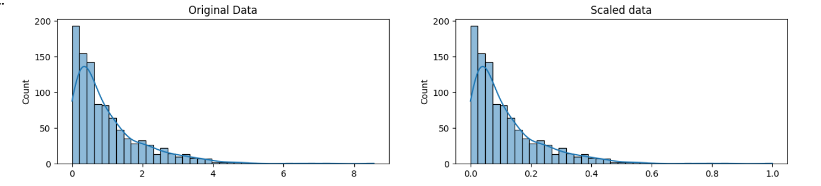

# plot both together to compare
fig, ax=plt.subplots(1, 2, figsize=(15, 3))
sns.histplot(original_data, ax=ax[0], kde=True, legend=False)
ax[0].set_title("Original Data")
sns.histplot(normalized_data[0], ax=ax[1], kde=True, legend=False)
ax[1].set_title("Normalized data")
plt.show()
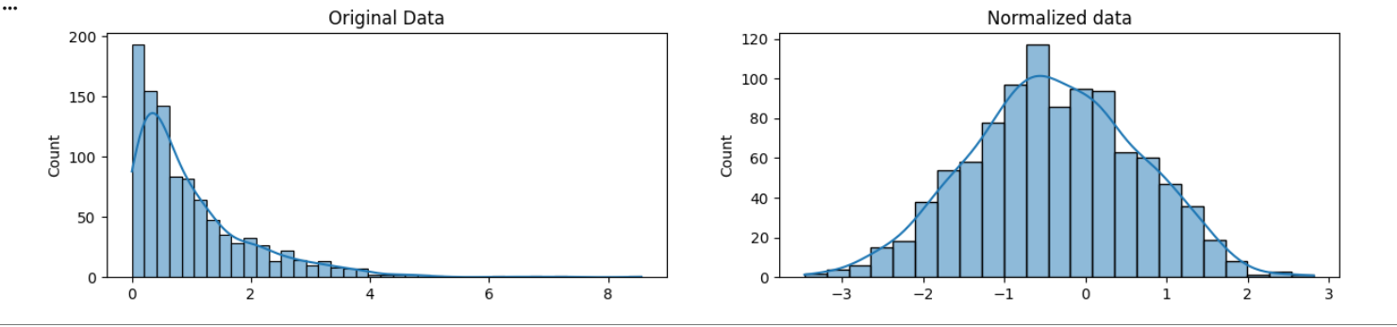

3.Parsing Dates
#parsing data
import pandas as pd
import numpy as np
import seaborn as sns
import datetime
# set seed for reproducibility
np.random.seed(0)

sns.countplot(
data = df,
x = "depression_label",

)
num_cols = df.select_dtypes(include = ["int64",'float']).columns
plt.figure(figsize = (15,10))

for i,col in enumerate(num_cols,1):
plt.subplot(4,3,i)
sns.histplot(df[col],kde = True)
plt.tight_layout()
plt.show()
plt.figure(figsize=(10, 8))
sns.heatmap(df.corr(numeric_only=True), annot=True, cmap="coolwarm", fmt=".2f")
plt.title("Correlation Heatmap")
plt.show()
cat_cols = df.select_dtypes(include = ["object","category"]).columns
for col in cat_cols:
display(
df[col].value_counts().rename_axis(col).reset_index(name = "Count")
)

4.Character encodings
import charset_normalizer
before = "This is the euro symbol: €"
type(before)
after = before.encode("utf-8", errors="replace")
type(after)
after
print(after.decode("utf-8"))
before = "This is the euro symbol: €"
errors
after = before.encode("ascii", errors = "replace")
print(after.decode("ascii"))
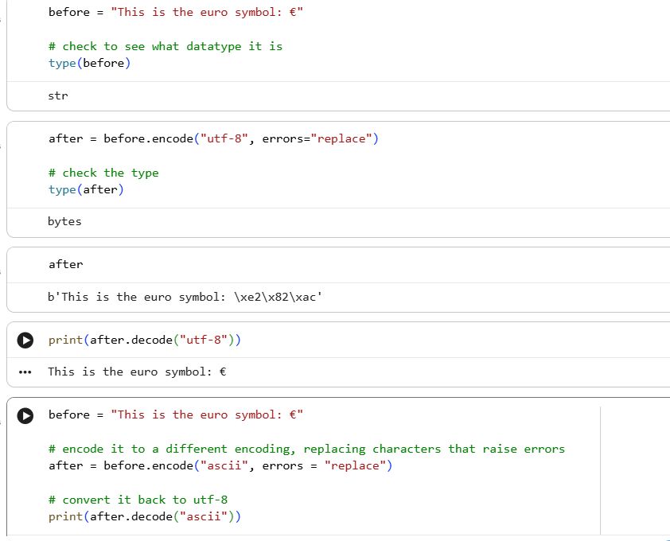

5.Inconsistent data entry
import pandas as pd
import numpy as np
!pip install fuzzywuzzy
import fuzzywuzzy
from fuzzywuzzy import process
import charset_normalizer
professors = pd.read_csv("/content/pakistan_intellectual_capital-selected-columns.csv")
np.random.seed(0)
countries = professors['Country'].unique()
countries.sort()
countries
professors['Country'] = professors['Country'].str.lower()
professors['Country'] = professors['Country'].str.strip()
countries = professors['Country'].unique()
countries.sort()
countries
matches = fuzzywuzzy.process.extract("south korea", countries, limit=10, scorer=fuzzywuzzy.fuzz.token_sort_ratio)
matches
def replace_matches_in_column(df, column, string_to_match, min_ratio = 47)
strings = df[column].unique()
matches = fuzzywuzzy.process.extract(string_to_match, strings,
limit=10, scorer=fuzzywuzzy.fuzz.token_sort_ratio)
close_matches = [matches[0] for matches in matches if matches[1] >= min_ratio]
rows_with_matches = df[column].isin(close_matches)
matches
df.loc[rows_with_matches, column] = string_to_match
print("All done!")
replace_matches_in_column(df=professors, column='Country', string_to_match="south korea")
countries = professors['Country'].unique()
countries.sort()
countries


6. outliers
import pandas as pd
import seaborn as sns
import matplotlib.pyplot as plt

data = {"IQ": [95, 102, 98, 110, 105, 99, 101, 97, 150, 72]}
df = pd.DataFrame(data)

sns.boxplot(x=df["IQ"])
plt.title("Box Plot for IQ Data")
plt.show()
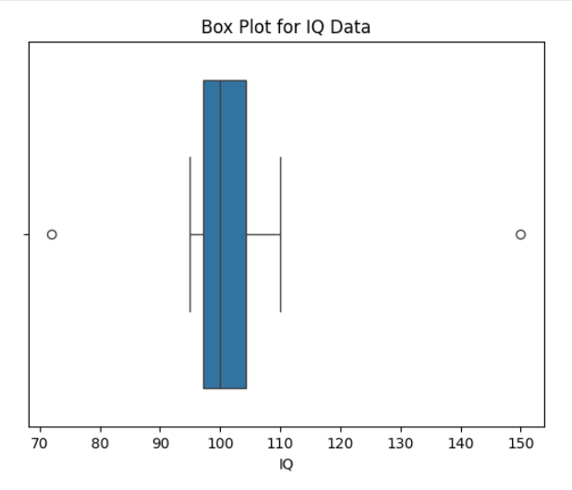
plt.scatter(df.index, df["IQ"])
plt.xlabel("Index")
plt.ylabel("IQ")
plt.title("Scatter Plot for IQ Data")
plt.show()
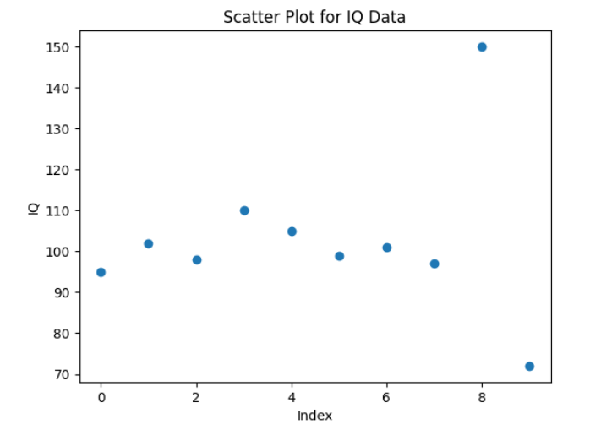
import pandas as pd
import numpy as np
from scipy.stats import zscore

np.random.seed(0)
normal_iq = np.random.normal(100, 5, 100)
outliers = [30, 250]

iq_data = np.concatenate([normal_iq, outliers])

df = pd.DataFrame({"IQ": iq_data})
df["Z_Score"] = zscore(df["IQ"])

outliers_z = df[np.abs(df["Z_Score"]) > 3]
print(outliers_z)

output:
IQ Z_Score
100 30.0 -4.156281
101 250.0 8.708296
Q1 = df["IQ"].quantile(0.25)
Q3 = df["IQ"].quantile(0.75)
IQR = Q3 - Q1

lower_bound = Q1 - 1.5 * IQR
upper_bound = Q3 + 1.5 * IQR

outliers_iqr = df.query("IQ < @lower_bound or IQ > @upper_bound")
print(outliers_iqr)

from sklearn.cluster import DBSCAN

dbscan = DBSCAN(eps=5, min_samples=2)
df["Cluster"] = dbscan.fit_predict(df[["IQ"]])

outliers_dbscan = df[df["Cluster"] == -1]
print(outliers_dbscan)

output:
IQ Z_Score Cluster
100 30.0 -4.156281 -1
101 250.0 8.708296 -1
from sklearn.ensemble import IsolationForest

iso = IsolationForest(contamination=0.2, random_state=42)
df["Outlier"] = iso.fit_predict(df[["IQ"]])

outliers_iso = df[df["Outlier"] == -1]
print(outliers_iso)

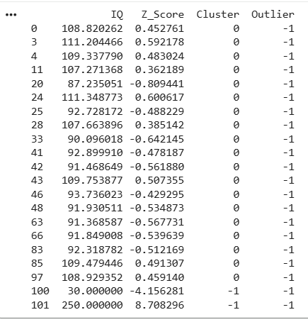
7.Duplicates removal
import pandas as pd

data = {
'Name': ['Alice', 'Bob', 'Alice', 'Charlie', 'Bob', 'David'],
'Age': [25, 30, 25, 35, 30, 40],
'City': ['New York', 'Los Angeles', 'New York', 'Chicago', 'Los Angeles', 'San Francisco']
}

df = pd.DataFrame(data)
df
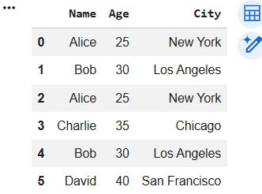
duplicates = df.duplicated()

duplicates
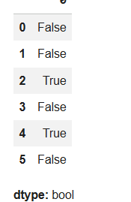
df_no_duplicates_columns = df.drop_duplicates(subset=['Name', 'City'])
(df_no_duplicates_columns)
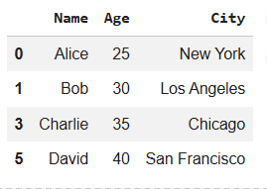
df_keep_last = df.drop_duplicates(keep='last')
(df_keep_last)
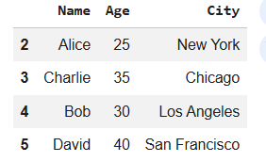
8.Fuzzy matching
# Install openpyxl (if needed)
!pip install openpyxl

import pandas as pd
import sqlite3

# Upload the Excel file
from google.colab import files
uploaded = files.upload()

# Read the Excel file
df = pd.read_excel("FirstName_LastName_Data.xlsx")

# Rename columns to match your SQL query
df.columns = ['firstName', 'lastName']

# Create SQLite connection
conn = sqlite3.connect(':memory:')

# Register SOUNDEX function (SQLite already supports it)
df.to_sql('load', conn, index=False, if_exists='replace')

# Execute SQL query
query = """
SELECT DISTINCT
ss.firstName,
ss.lastName,
sd.firstName,
sd.lastName
FROM load AS ss, load AS sd
WHERE ss.firstName = sd.firstName
AND SOUNDEX(ss.lastName) = SOUNDEX(sd.lastName)
AND substr(ss.lastName,1,2) = substr(sd.lastName,1,2)
AND ss.lastName <> sd.lastName;
"""

result = pd.read_sql_query(query, conn)

# Display result
print(result)

